Total # of Classes: ______
Private Lesson ______
Deposit Amount: ______
TOTAL: ________________

PAID: Ck# _______
Cash _______
Balance Due: ___________
Spring 2021 – Session 1: June 7-July 2 & Session 2: August 2-August 27
NO in-person registration due to COVID – send an email to MainSt56DanceCompany@gmail.com stating the classes you or your child/ren wish to take. Bring your registration form/s and money to the first class!
Student Name _________________________________________
D.O.B. _____________ Age ______ Grade (if applicable) _______
School (if applicable) ___________________________________________
Home Address
_______________________________________________________________________
Parent or Guardian (under 18)________________________________________________________
Contact Phone_________________________ Email_____________________________
Emergency Contact Name and Number_______________________________________
ALLERGIES_______________________________________________________________
Any Medical or other information staff should be aware of:
________________________________________________________________________
Theater or Dance experience _______________________________________________
________________________________________________________________________
________________________________________________________________________
Names and Phone Numbers of those permitted to pick your child up from class (if applicable) -
1.______________________________________________________________________
2.______________________________________________________________________
3.______________________________________________________________________
I do____ I do not_____ give my permission for my child to be included in photography/video of this program, and for his/her image and likeness to be used in advertising, press releases, or reporting regarding same, in electronic or print media, without expectation of recompense.

Please sign and date _____________________________________________________

OUR MISSION: To provide a safe, respected and quality dance program that is designed to be student oriented, parent supported and staffed with excellence.
OUR GOAL: To establish a group of young dancers that will participate in dance performances, theater productions, as well as attempt to learn different types of movement and dance techniques at an affordable rate.

Please Circle Desired Classes:

*schedule/room assignments are subject to change

Session #1: June 7-July 2

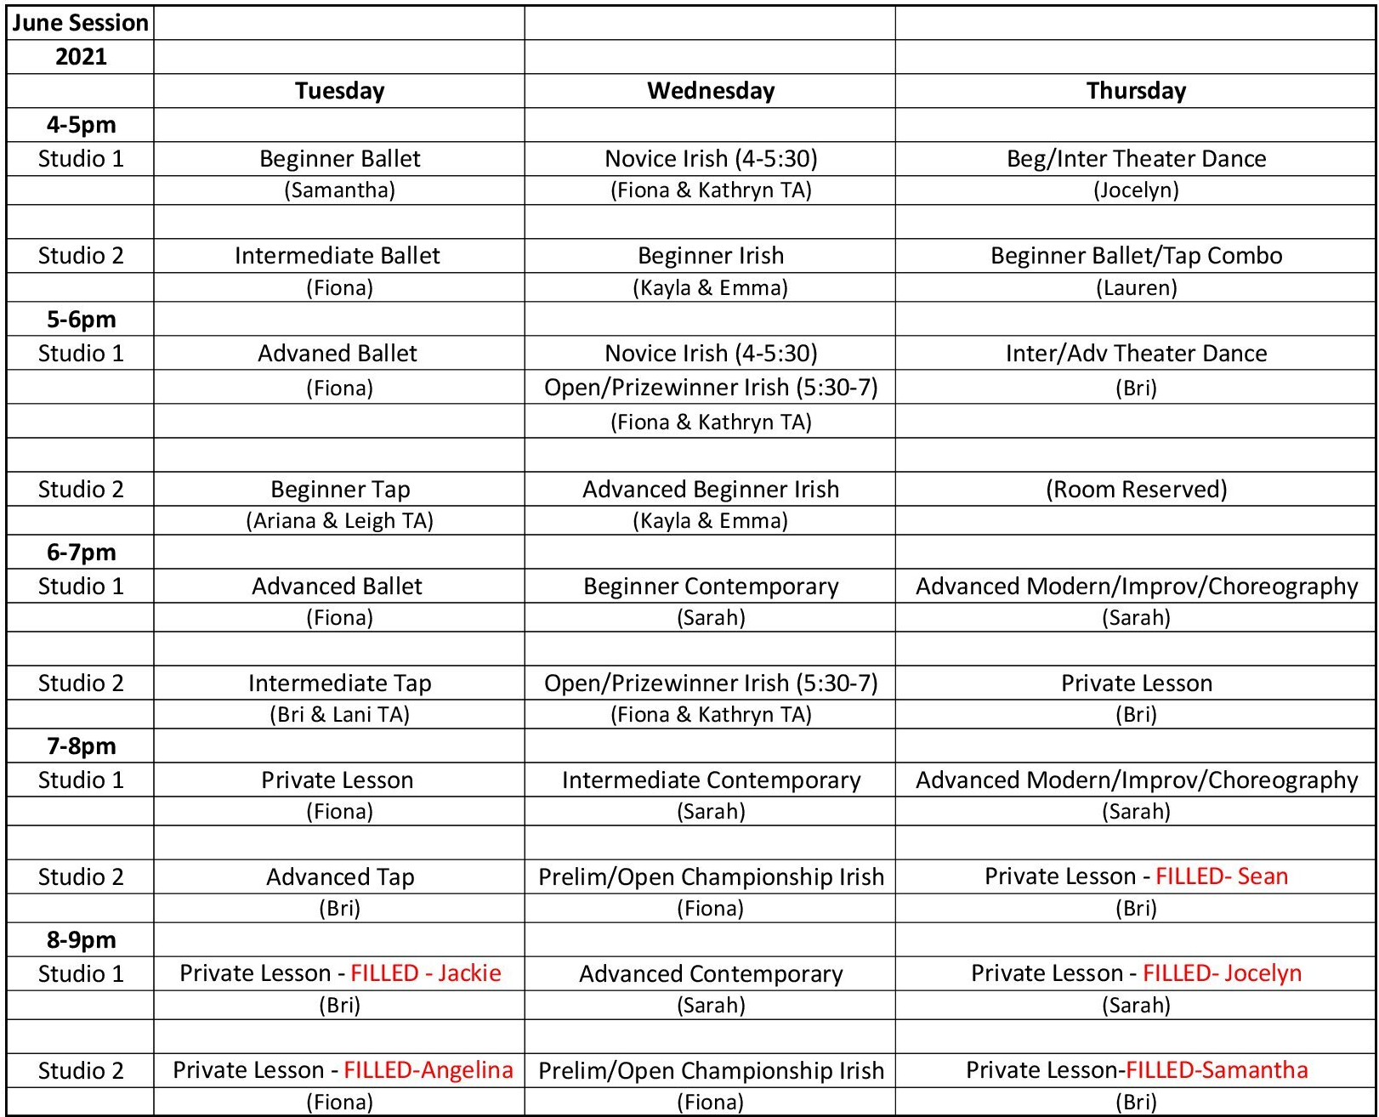

Session #2: August 2-August 27

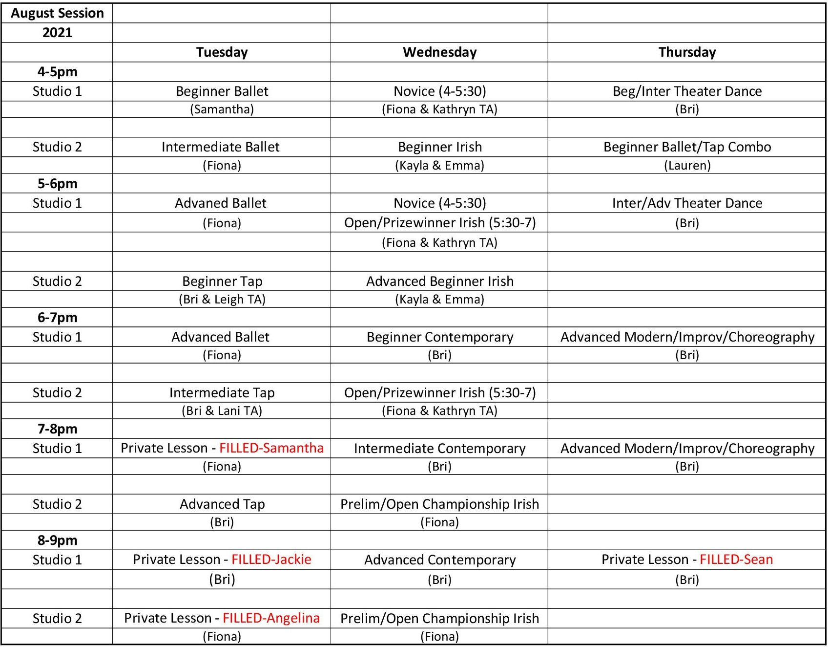

Are you interested in a private lesson? YES NO
*Private Lessons will be scheduled with the desired instructor, as long as the studio schedule and the instructor’s schedule allow it*
Are you interested in Competition? YES NO
*This will help us plan for next season!*

Keep an eye out for workshops/masterclasses throughout the summer!

SUMMER COSTS:

-1 hour classes - $50 per class, per session ($100 if you take a class both sessions)
-1 ½ hour classes - $62.50 per class, per session
-2 hour classes - $75 per class, per session
-Tuition can be paid weekly or in-advance –
*all payments during the summer should be given to an instructor who will place it in the red dropbox*
-TUTION MUST BE PAID IN FULL BY THE END OF SUMMER
– If you have an unpaid balance from a previous semester, you/your child will not be able to register for the classes until your balance has been paid in full.
-FAMILY DISCOUNT –
- Take 5% off each additional child after the first full price child
- For immediate family members only
- Discount will be taken off the lower priced package
-10% OFF entire tuition if PAID IN FULL THE FIRST WEEK OF CLASSES
-Students taking 4 or more classes will receive 10% off their tuition for the session even if not paying in full.
-$35 Return Check Charge
-Private Lesson is $15 per person for a half an hour. $20 per person for an hour.

**WE DO NOT OFFER DROP-IN CLASSES

**IF YOU REGISTER FOR A CLASS, YOU ARE EXPECTED TO PAY THE FULL AMOUNT (you can not pay only for the classes attended that session. Absences do not subtract from the total amount!)

All Sign-ups are first come first serve

Classes are capped at 8 for Studio 1 and 6 for Studio 1

*Beginner, Intermediate and Advanced are meant to be used as a general guide only. Please place yourself or your child in the appropriate level based on their previous experience. If you have any questions on which level is best for you or your child, please, don’t hesitate to ask.

**If it seems a student has been placed in the incorrect level we will discuss moving them to the correct one within the first month of classes. The instructors will be communicating with each other so the decision to move a student will be discussed and well thought out. We want to provide the best possible education for each student.

Participation Agreement and Waiver

Under 18**
I, _______________________________, am the parent/guardian of _____________________________. I give my permission for my son/daughter to participate in the Dance Company programs and performances, offered by Batavia Players. I understand that although the students will be supervised by staff, I do assume the risk in my student’s participation in this program. I acknowledge that I will not seek to have Main St. 56 Dance Company, Main St. 56 Theater, or Batavia Players or its staff held liable in the event that any accident, injury, loss of property or any other circumstance or incident occurs during or as a result of my son’s/daughter’s participation in this program. This release of liability includes accident, injury, loss, or damages to the student, as well as, to other individuals or property which may result from the student’s participation in this program. I hereby release and agree to hold harmless Main St. 56 Dance Company/Main St. 56 Theater/ Batavia Players, its officials, agents and employees, from any claims arising out of my son’s/daughter’s participation in this program. I have read and understand and accept all of the statements above and accept full responsibility as described.
I understand that my child’s participation in the activity is a privilege, and that rules of acceptable behavior apply. I acknowledge that I have reviewed with my child the rules and requirements established for this activity; all policies and procedures; rules of conduct set forth in the Student Code of Conduct, and that they understand the need to abide by them in order to participate.

(Parent/Guardian) Sign and Date_________________________________________________________

Over 18**
I ________________________________________ understand that although the students will be supervised by staff, I do assume the risk in my participation in this program. I acknowledge that I will not seek to have Main St 56 Dance Company, Main St. 56 Theater, or Batavia Players or its staff held liable in the event that any accident, injury, loss of property or any other circumstance or incident occurs during or as a result of my participation in this program. This release of liability includes accident, injury, loss, or damages to the student, as well as, to other individuals or property which may result from the student’s participation in this program. I hereby release and agree to hold harmless Main St. 56 Dance Company/Theater/ Batavia Players, its officials, agents and employees, from any claims arising out of my participation in this program. I have read and understand and accept all of the statements above and accept full responsibility as described.
I understand that my participation in the activity is a privilege, and that rules of acceptable behavior apply. I acknowledge that I have reviewed the rules and requirements established for this activity; all policies and procedures; rules of conduct set forth in the Student Code of Conduct, and that they understand the need to abide by them in order to participate.

Sign and Date_________________________________________________________

Assumption of the Risk and Waiver of Liability Relating to Coronavirus/COVID-19

Student: __________________________________

The novel coronavirus, COVID-19, has been declared a worldwide pandemic by the World Health Organization. COVID-19 is extremely contagious and is believed to spread by various methods, including person-to-person contact and contact with contaminated surfaces. It is believed that people who have COVID-19, but do not show symptoms, are still able to spread the virus. As a result, federal, state, and local governments and federal and state health agencies recommend social distancing and have, in many locations, prohibited the congregation of groups of people.

The Main St. 56 Dance Company (M56DC) has put in place preventative measures to reduce the spread of COVID-19; however, M56DC cannot guarantee that you or your child(ren) will not become infected with COVID-19. Further, attending M56DC could increase your risk and your child(ren)’s risk of contracting COVID-19, even though all preventative measures are being followed.

By signing this agreement, I acknowledge the contagious nature of COVID-19 and voluntarily assume the risk that I and/or my child(ren) may be exposed to or infected by COVID-19 by attending M56DC. I understand that the risk of becoming exposed to or infected by COVID-19 at M56DC may result from the actions of myself and/or others, including, but not limited to, M56DC employees, volunteers, and program participants and their families.

I voluntarily agree to assume all of the foregoing risks and accept sole responsibility for any injury to my child(ren) or myself. Possible risks that I or my child(ren) may experience or incur in connection with my child(ren)’s attendance at M56DC or participation in M56DC classes are, but are not limited to: illness (including, but not limited to, personal injury, disability, and death), damage, loss, claim, liability, or expense, of any kind. On my behalf, and on behalf of my children (if they are students at M56DC), I hereby release, covenant not to sue, discharge, and hold harmless M56DC, its employees, agents, and representatives, of and from the Claims, including all liabilities, claims, actions, damages, costs or expenses of any kind arising out of or relating thereto. I understand and agree that this release includes any Claims based on the actions, omissions, or negligence of M56DC, its employees, agents, and representatives, whether a COVID-19 infection occurs before, during, or after participation in any M56DC program, class or event.

Print Name (Parent/Guardian if student is under 18) ____________________________________________

Sign _________________________________________________ Date ____________________

Student Code of Conduct
I am a member of a cooperative team of learners and performers. I agree to:
- Follow all COVID-19 rules and guidelines: drop-off and pick-up guidelines, daily questionnaires, masks, social distancing, etc…
- Exhibit respect toward others. Bullying, inappropriate language, exclusionary behavior, or disrespect towards peers or staff will not be tolerated.
- Conduct myself in a responsible manner.
- Obey all academy rules, including safety rules.
- ATTENDANCE is crucial; each missed classed is missed material, information and necessary practice. Remember, we only have 14 classes in each semester! We are not required to make up any classes missed by a student!
- ABSENCES – we understand that everyone gets sick and has important occasions that will cause students to miss class once in a while. We ask that you give us as much notice as possible. You still pay for class even if you’re absent!!!
- ARRIVE early for classes.
- CLASS ATTIRE – there is no strict dress code. We do, however, ask students wear clothing that allows the instructors to see correct alignment and placement.
  - No loose/baggy clothing.
  - No dangling or large jewelry.
  - Hair should be up and pulled away from your face.
  - Pants should not be too long – tripping hazard
  - Appropriate shoes should be worn for specific classes:
    - Ballet = ballet shoes
    - Theater = jazz shoes
    - Jazz/Contemporary = jazz or lyrical shoes
    - Tap = tap shoes
    - Irish = soft or hard shoes
      - No food in the studios
      - No street shoes on the dance floors
      - Bring a reusable water bottle to all classes
      - CANCELLATION POLICY – If the Batavia schools are closed due to extreme weather, the studio will close as well. If an instructor must cancel their classes, we will inform you as soon as possible! If any classes are cancelled you will receive an email and we will also post the information on our Facebook page! We will make up any cancelled classes. We are not required to make up any missed classes by the student!!

ELECTRONICS: Cell phone use is not permitted during class. Phones are to remain in backpacks or with belongings; if students need to make a call, a staff member will supervise use and require phone to be put away before the student rejoins group. NO OTHER ELECTRONIC DEVICES. If a student is found using electronic devices during program time, the device will be removed and kept by senior staff until the student is picked up at end of their session.

(Student) Sign and Date_________________________________________________

(Parent/Guardian, if under 18) Sing and Date __________________________________________________

HIGHLIGHTS & BENEFITS
• NO COSTUME FEES – Costumes will be approved but we are not recital based, only performance based. If specific costumes were required or parents want them, it would be at cost plus a small handling charge for ordering etc. NO EXTRAVAGANT costume fees.
• SMALL CLASSES – Class sizes are meant to be more individual based with a higher concentration of teacher/student ratio. Class sizes can only be plus one of specific size.
• SEMESTER BASED STRUCTURE - Not a full year commitment. A performance space/venue will be established at the end of each semester at the Main St 56 Theater or another Venue. Students are NOT REQUIRED to
appear in Main St 56 Theater productions but will be considered as other cast members. Dance number in the Christmas Show will be done by Dance Company students/members if they wish to participate. We have an Informal Showing in the Fall and a Dance Concert in the spring.
• COMPETITIVE TEAM AVAILABLE - Competition participants will pay their own Competition Fees at Cost. No other Fees will be charged for Competitions. Parents of Competitive Students will decide Competition Schedule and level of participation.
• RESPECTED STAFF – Our instructors are qualified, enthusiastic and completely invested in providing a quality dance education. Our instructors are carefully selected to create a well-rounded team!
• PARENTS CAN CUSTOMIZE SERVICE – If a parent wishes to hire a Staff Member for Additional Hours, etc. They can make the arrangements with the Individual Staff Member at our hourly rate and still use our facility.
• GOOD LOCATION – While our location will not be admittedly totally complete or perfect, we will do our best to improve and increase the quality of our services and our location as we move forward. With the support of our parents, community and theater, we will be able to make improvements on a regular basis. Our location is centrally located.
​
• NON-PROFIT STATUS – This is perhaps our number one advantage. Our Dance Program is and will continue to be a non-profit program. We will look for grants, ask parents for help and try to establish as many programs that
will support our Mission and Goal. The PARENTS ADVISORY COMMITTEE will decide and conduct ONE fundraiser per semester to help support the program. That is all we ask.

I have read the highlights and benefits: _______________________________________________
Signature (Parent/Guardian, if under 18)

